Chapter 8, Problem 4.

In the circuit of Fig. 8.65, find:

(a) v(0⁺) and i(0⁺),

(b) dv(0⁺)/dt and di(0⁺)/dt,

(c) v(∞) and i(∞).

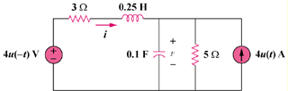

Figure 8.65
For Prob. 8.4.

